Project: Instruments and their Players

1. Tabla

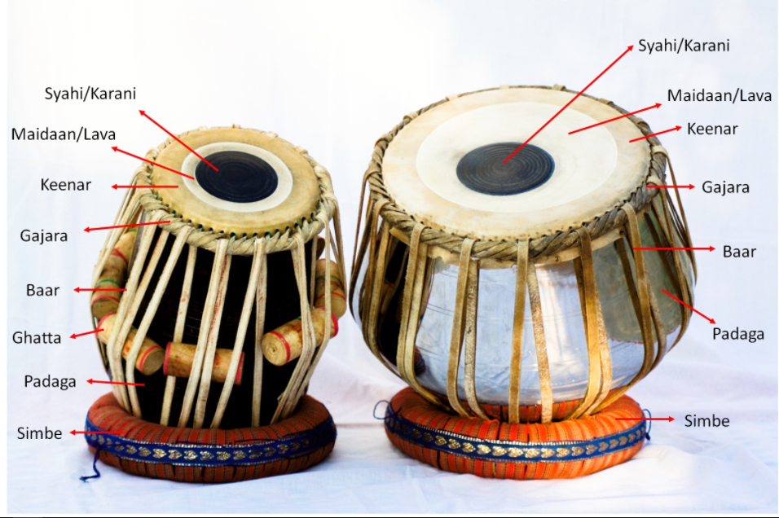

Players:

Ustad Zakir Husain ji

1. Sarangi

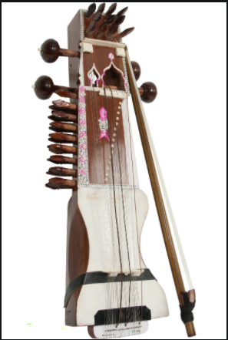

Players:

Ustad Sultan Khan ji

1. Sitar

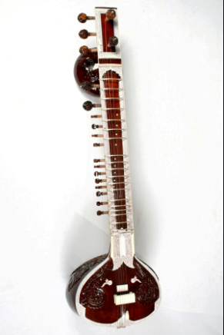

Players:

Pandit Ravi Shankar ji

1. Sarod

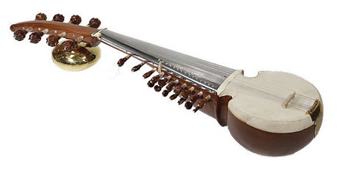

Players:

Ustad Amjad Ali Khan ji

1. Shehnai

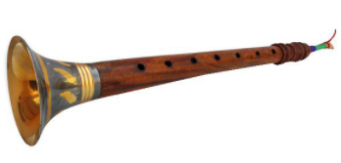

Players:

Ustad Bismillah Khan ji

1. Harmonium

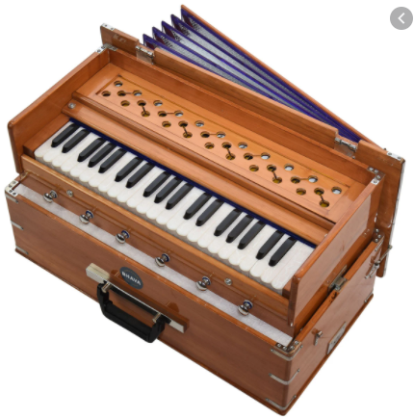

Players:

Pandit R.K Bijapure ji

1. Mridangam

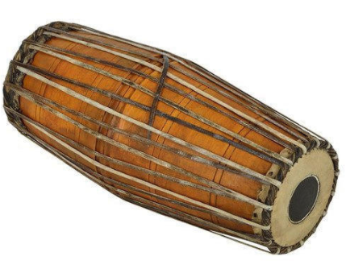

Players:

Palani Subramaniam Pillai ji

1. Dholak

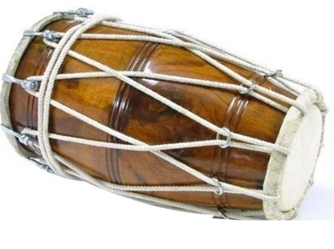

Pandit Girish Vishwa ji

1. Pakhwaj

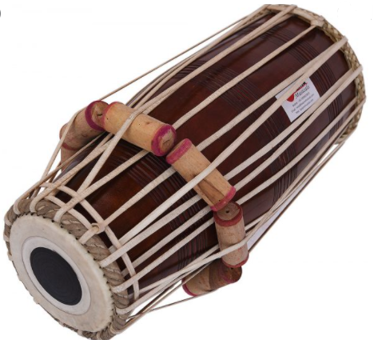

Players:

Pandit Mohan Shyam Sharma ji

1. Ghatam

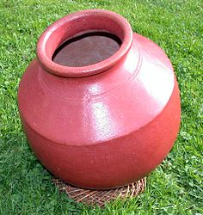

Players:

Pandit Thetakudi Harihara Vinaykram ji